Project Design Phase-II
Data Flow Diagram & User Stories

Date | 15 February 2026
Team ID | LTVIP2026TMIDS79623
Project Name | Educational Organisation Using ServiceNow
Maximum Marks | 4 Marks

Data Flow Diagrams:
A Data Flow Diagram (DFD) is a traditional visual representation of the information flows within a system. A neat and clear DFD can depict the right amount of the system requirement graphically. It shows how data enters and leaves the system, what changes the information, and where data is stored.
Data Flow Diagram (DFD) - Educational Organisation System :
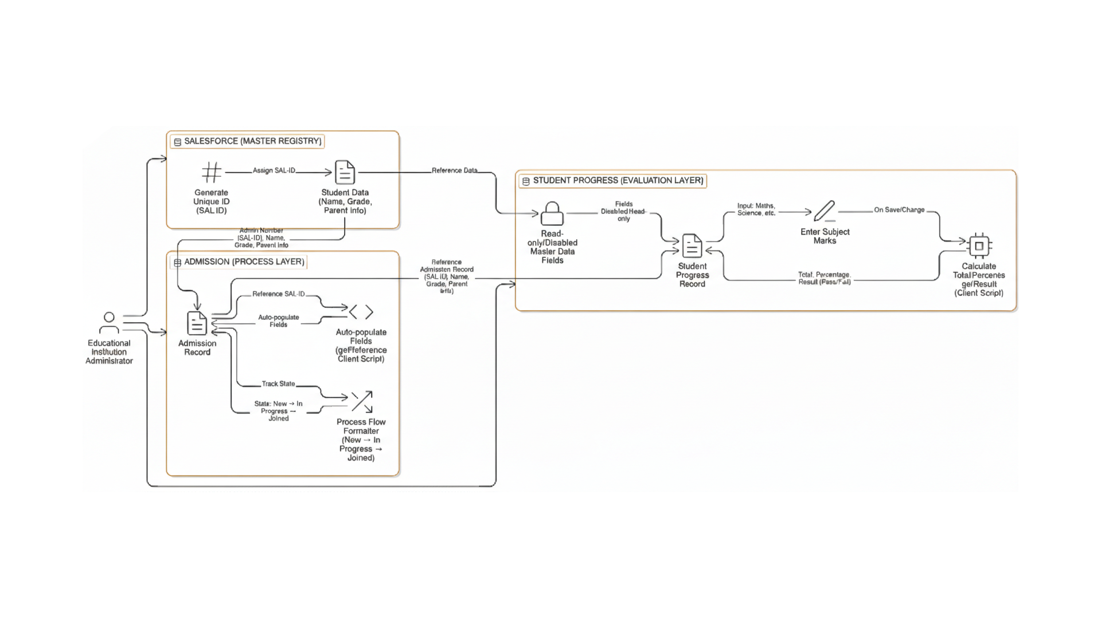
User Stories
User Type | Functional Requirement (Epic) | User Story Number | User Story / Task | Acceptance criteria | Priority | Release
Administrator | Instance Setup | USN-1 | Open and configure the Personal Developer Instance (PDI). | PDI is active and ServiceNow Studio is accessible. | High | Sprint-1
Administrator | Configuration Setup | USN-2 | Create and manage a local update set. | All configurations are captured for easy migration. | High | Sprint-1
Administrator | Table Creation | USN-3 | Create Salesforce table as a master registry. | Fields for Name, Grade, and Parent Info are saved. | High | Sprint-1
Administrator | Table Creation | USN-4 | Create Admission table for the process layer. | Table successfully links to the Salesforce master data. | High | Sprint-1
Administrator | Table Creation | USN-5 | Create Student Progress table for the evaluation layer. | Table supports entry of academic subject marks. | Medium | Sprint-1
Administrator | UI Configuration | USN-6 | Configure Salesforce table form layout. | Form fields are organized for easy data entry. | Medium | Sprint-2
Administrator | UI Configuration | USN-7 | Configure Admission table form layout. | Process-related fields are visible and grouped. | Medium | Sprint-2
Administrator | UI Configuration | USN-8 | Configure Student Progress table form layout. | Mark entry fields are clearly separated by subject. | Medium | Sprint-2
Administrator | Number Maintenance | USN-9 | Implement auto-number generation for admission IDs. | System assigns a unique SAL-ID upon record creation. | High | Sprint-2
Administrator | Process Flow | USN-10 | Configure process flow formatter for admission stages. | Visual bar shows states from "New" to "Joined". | Medium | Sprint-2
Administrator | Client Scripts | USN-11 | Auto-populate details using reference fields (getReference). | Selecting SAL-ID fills student Name and Grade automatically. | High | Sprint-3
Administrator | Client Scripts | USN-12 | Disable non-editable fields based on conditions. | Master data fields become read-only in the progress record. | Medium | Sprint-3
Staff/Teacher | Logic & Calculation | USN-13 | Calculate total marks automatically via Client Script. | Total field updates instantly after entering marks. | High | Sprint-3
Staff/Teacher | Logic & Calculation | USN-14 | Calculate percentage automatically. | Percentage is computed accurately based on total marks. | High | Sprint-3
Staff/Teacher | Logic & Result | USN-15 | Generate result status automatically. | Status shows "Pass" or "Fail" based on percentage. | Medium | Sprint-3

